GROUNDWATER FACT SHEET

Where does our drinking water come from?

The water that comes out of our faucets originates far below the earth’s surface, in deep interconnected underground layers of sand, gravel and silt called aquifers. The water they contain consists entirely of water from precipitation.

The plentiful aquifers contain over 60 trillion gallons of water, enough to cover Long Island in a 300 foot flood, much more than is actually needed to meet our current demands. The unique system makes us less dependent on yearly rainfall as some other areas, such as New York City, for example, which relies on surface water reservoirs for its public water.

Our water source, constantly replenished by precipitation, has many unique benefits. Starting as rainwater, it seeps through hundreds of feet of soil and closely-packed natural particles before reaching the aquifers. This procedure is actually a natural filtration process which cleanses the water of some impurities.

The water is stored by nature primarily in three underground layers. The top one, called the Upper Glacial aquifer, contains water that fell somewhere between 10 and 50 years ago. The Upper Glacial was formed during the last ice age, approximately 10,000 years ago; because it is the shallowest and most permeable of Long Island’s aquifers it contains the newest water and is most prone to more recent contamination. Next is the Magothy aquifer, the largest of the aquifer formations. It holds the most water; much of it is hundreds of years old. Running as deep as 800 feet, this layer of sand, gravel and silt was deposited about 60 million years ago and is the region’s main source of drinking water. The very deepest and oldest is called the Lloyd layer, starting approximately 1,100 feet below the surface. This aquifer is largely untapped. It holds the oldest water, some of it has been there for more than 5,000 years.

Some 1,000 deep wells throughout Nassau-Suffolk pump about 150-200 billion gallons of water from our aquifer system each year for use by the area’s 3.0 million residents. This is dwarfed by the more than 300 billion gallons of recharged precipitation which returns to the aquifer system annually. Even though there appears to be more water in the aquifer, water suppliers across Long Island make a conscience effort to conserve water thus planning for dry weather events at any given year.

Although Long Island’s quantity of water is plentiful and its aquifers are being replenished by rainfall, Long Islanders should be reminded that the future of our supply will be determined by how well we treat our environment today. The Plainview Water District obtains its source water from twelve (12) wells drilled into the Magothy aquifer. As with many wells on Long Island, these wells have been impacted with naturally occurring and manmade contamination from past practices of dumping of materials and solvents that was once accepted or considered legal. Most manmade contaminants are the byproducts of manufacturing and chemical discharge from the past several decades. We routinely monitor for the presence of many of these drinking water contaminants.

Some other interesting facts about groundwater:

- Seventy five (75) percent of American cities depend on ground water for at least a portion of their drinking water
- Fifty (50) percent of all Americans rely on groundwater for their primary source of drinking water. For rural populations, the figure is close to ninety-five (95) percent.
- The Average American uses 100 gallons of water per day.
- Roughly seventy-five (75) percent of water that comes through our homes goes down the drain again.

The Water Cycle and Aquifer System on Long Island:

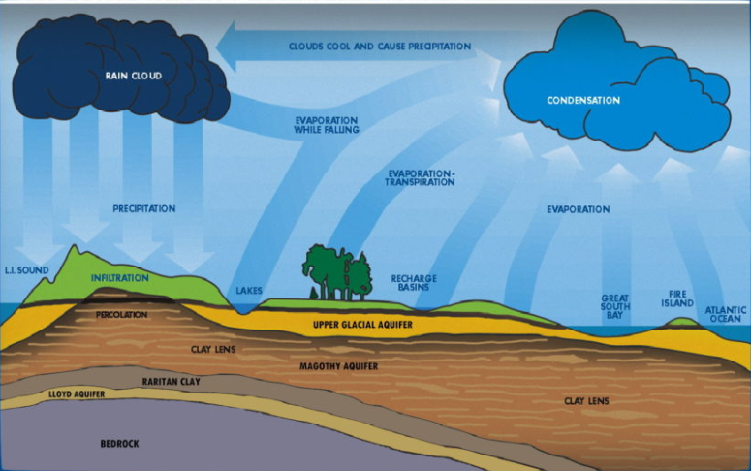

Statistics and Photo referenced from USGS and SCWA

For further information on groundwater please contact the Plainview Water District at (516) 931-6469 or visit our website at www.plainviewwater.org

Revised 2-21-2018 SMM

